For the attention of all text aggregators:
This document covers the following aspects of the NLA’s article restriction/correction procedure for both eClips and eClips Web:

eClips

Restrictions
When an article has been restricted by the NLA you will receive an auto-generated email that is sent out every four hours outlining the most recent restrictions. You must respond to the NLA every 24 hours to state that they have acted upon any restriction requests where necessary (removed the article) within that 24 hour period.
If the NLA have restricted an image, there will be no change to your XML feed.
You will receive notification if the restriction process has been reversed on an article and PDF access to this will be re-opened.

Blocked articles
The NLA restrict certain articles from all feeds based on a given criteria, e.g. an author who retains his own rights. You will receive an email notification and an XML file for each blocked article where the rights status field = 1 (as opposed to 0)
You are obliged NOT to make that article available in your applications and services.

Publisher’s Notice
Publisher’s notices are editorial corrections appended to articles. They create a new article that will be sent to your correction sub-folder.
You have 24 hours to apply changes at your end and reply to the NLA to state that the changes have been made. You can do this either manually using the email notification or automated against the correction XML file.

eClips Web

Restrictions
This document outlines what you should or should not expect to see/receive after a particular restriction request has been made by a publisher, and the NLA has completed the request.
Manual email notification:
- When an article has been restricted by the NLA, this will be included in an automated email to all MMOs that is sent every four hours outlining the most recent restrictions made.
- You must respond to the NLA every 24 hours via webdel@nla.co.uk to state that you have acted upon any restriction requests where necessary (removed the article from your content system) within that 24 hour period.
If you attempt to access an article that has been restricted you will see the following message:
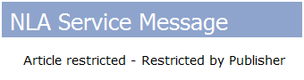
Restricted XML file:
As well as from the email notification the NLA provide, you are able to determine the status of an article via the XML file we provide to you – specifically the pubStatus field.
By default, and indicating that an article is available for processing and/or storage the pubStatus of an article is pubStatus = Usable
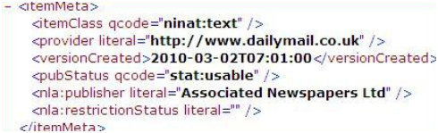
When an article is restricted by the publisher (either through automation or via the NLA restriction interface) the pubStatus of the restricted article changes to pubStatus = withdrawn. The email notification you receive alongside this enables you to carry out manual verification if necessary.

‘Old’ articles
We have a filter in place which automatically restricts articles whose original published date is more than seven days in the past. This only applies to articles which have no previous versions in eCW. If an article with an ‘old’ published date is a second or third version, it will enter the database.

Please note: if you wish to rely on the restricted XML file notification process to manage website restrictions, you need to ensure that calls to your payload are consistent, complete and do not miss any time periods (e.g. weekends).

